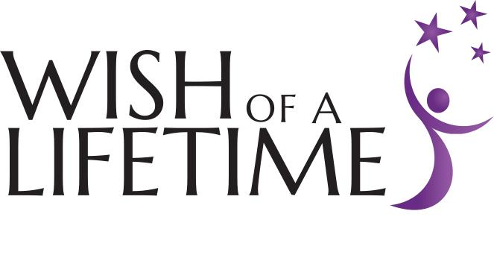
Public Relations/Social Media
Internship

Wish of a Lifetime (WOL) is a nonprofit based in Denver, CO whose mission is to shift the way society views and values our oldest generations by fulfilling seniors’ dreams and sharing their stories to inspire those of all ages. These meaningful experiences connect seniors with the passions, people, and purpose that bring meaning and joy to life. By granting Wishes for deserving seniors, we aim to shift the way society views and values aging. Wish of a Lifetime strives to engage the community in supporting and celebrating these amazing seniors, and contributing to the accomplishment of their lifelong dreams.

Eligibility: The internship program is designed for individuals with the goal of becoming leaders in the non-profit sector. Interns work closely with staff members in a collaborative environment and during their term of service are expected to complete projects that contribute to the execution of the organization’s mission and vision. Ideal candidates will possess a desire to enact meaningful social change within the community. Participation will provide interns with the opportunity to gain skills and experience in communication, business writing, public relations, fundraising, social media, and marketing.

Positions: WOL offers both academic and non-academic internships. Internships provide the opportunity to engage in meaningful nonprofit work through WOL’s communications department. Public Relations/Social Media Interns could be asked to:

- Work with staff to manage the organization’s Facebook, Twitter, Instagram and Pinterest pages
  - Prepare news releases and other media materials for distribution to media outlets
  - Disseminate information on Wish program and Wish events
- Assist with inquiries and requests from regional and national media outlets
- Conduct local outreach to inform organizations and individuals about our Mission and uncover wishes for deserving seniors in the community
- Assist with ongoing and annual fundraising campaigns
- Maintain media asset libraries including Wish stories, photographs and video
- Assist in editing/writing Wish stories, web content and social media and marketing materials
- Collect and catalog Wish stories, photographs, video, art, etc. from a variety of sources, including chapter web sites and submissions, sponsors, and media
- Assist in developing and printing collateral for fundraising campaigns

Details:
- Interns receive a stipend; inquire in interview
- All positions are based in Denver, Colorado
- Some flexibility for working offsite is available
- Internships typically run for 12 weeks and are concurrent with the academic schedules of Colorado institutions of higher learning. WOL attempts to be flexible with internship scheduling.
- Accommodations will be made for holidays and academic and/or work schedules
- Interns are expected to follow the WOL Intern/Volunteer handbook and are responsible for fulfilling the time commitment as noted
- Interns are expected to fulfill a minimum of 16 hours per week
- Interns are responsible for their own transportation, parking and housing

Qualifications:
- Knowledge of the non-profit sector, either through coursework, volunteerism or employment experience.
- Excellent communication skills with the ability to confidently and clearly communicate information verbally and in writing.
- The ability to maintain a high level of confidentiality with information that will be obtained in daily interactions.
- Proficiency in all MS Office programs with an emphasis on MS Word, Excel, and internet research tools.
- Some volunteer experience preferred, although not required

General
- Other duties as assigned
- All interns are expected to spend a portion of their time engaged in administrative support to staff and Board of Directors

Application Process
- Please submit a cover letter and resume/work history via email or fax addressed to Sally Webster
  - sally@seniorwish.org
  - Fax: 303-648-5626
- We are interested in learning the following about you:
  - Academic and career goals
  - Skills, work and volunteer experience, coursework relevant to the internship
  - Employment history
  - Any information that you think will help explain why you should be chosen for this internship.
  - Why is it important to value senior citizens?
  - Availability and schedule preferences
- Applications will be accepted until a suitable candidate is chosen for each available position

