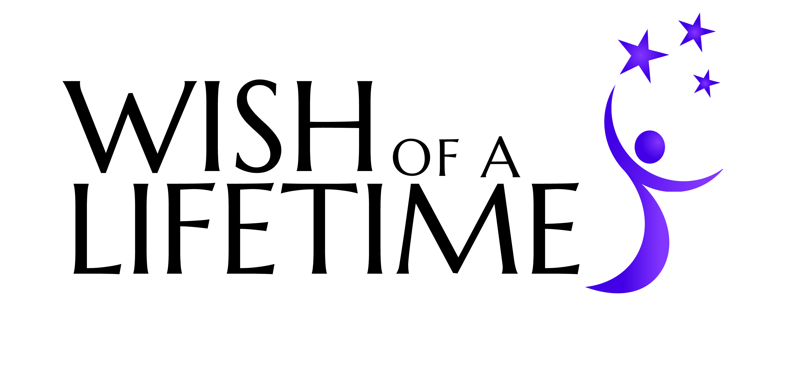
Wish Application
Please see our Guidelines at the end of the application to make sure the wish meets our criteria. Wishes that do not meet our criteria will not be considered for fulfillment. If you are nominating a senior for a wish, please remember that all questions refer to the senior you are nominating. Please be as thorough as possible to ensure your application is considered.

Section A: Contact Information
Senior
Senior Name:
Senior Phone Number:
Address:
City:
State: Zip:
Birthdate: Email:

Nominator (if applicable)
Nominator Name:
Nominator Phone:
Address:
City:
State: Zip:
Email:
Relationship to Wish Nominee:

Section B: Wish Details
Please be specific in your answers, and include as much detail as possible.
1. What is your Wish of a Lifetime?

2. Explain the history behind this wish:
2a) What makes this wish meaningful to you? (300 character minimum)

2b) What prompted this wish? (100 character minimum)

2c) When did you know or first realize you wanted this wish? (100 character minimum)

3. Describe any benefits (emotional, physical, spiritual, social or intellectual) you think you will experience as a result of having this wish granted: (100 character minimum)

4. How would granting this wish inspire others and help WOL in their goal to change the way people view aging?
This wish and/or my story will inspire others because… (100 character minimum)

5. Why are you unable to fulfill this wish on your own? (100 character minimum)

5a) Have you done this before? If so, how long has it been?

5b) If you are looking to reconnect with someone, when was the last time you saw them?

Section C: Personal History
Before we move forward with a wish, we would like to try and get to know you. Please take the time to tell us a little about yourself. Nominators: Please remember that all questions refer to the senior you are nominating.
1. What were your past occupations, if any?

2. What are some of your interests, hobbies, and passions? Do you still participate in any of these today? (100 character minimum)

3. What have you done to give back to others? (100 character minimum)
- What volunteer work do you do now or have you done in the past? Please specify what organizations you volunteered for and for how long.
- If you were a member of the military, please list branch and describe your service. Include your duties and list any battles or campaigns you were a part of as well as any medals or honors you received

3. Have you ever been convicted of a crime? Yes No
If yes, please provide details:

4. Are you a legal resident or citizen of the U.S.? Yes No
5. Are there any physical or cognitive impairments that may influence your ability to participate in the wish? (Please consider accommodating for wheelchairs, oxygen, dementia care, etc.) Please note: WOL tries to make every effort to accompany for cognitive and physical impairments when planning Wishes.
Yes No
If yes, please describe, and let us know what accommodations will need to be made to enable the Senior to fulfill his/her wish:

Section D: Medical Verification and Liability Release
Medical Verification Form – If your wish involves any extreme physical activity or travel of any kind, please have your doctor sign and submit the accompanying Medical Verification Form.
Photo and Liability Release – Please sign and submit the Photo and Liability Release Form along with your application. Receipt of the signed liability section is required for wish fulfillment. Photo release section is optional, but encouraged.

This application can be mailed to:

JBWOL Photo and Liability Release
Wish of a Lifetime
110 16th Street Suite 406
Denver, CO 80202

Or faxed to 303-648-5626

Certification
By signing below, I acknowledge that acceptance of this application by Wish of a Lifetime (WOL) does not constitute a commitment by WOL to fulfill my wish request. If WOL determines that this wish should enter the next stage of the wish process, a WOL representative will contact me for more information. I understand that this contact also does not constitute a commitment to grant my wish. Furthermore, I certify that I meet all qualifications for eligibility, and declare that all of the information given by me in this application is true to the best of my knowledge, and I agree to inform WOL in a timely manner should any information provided in this application change.
Signed Name:
Printed Name: Date:

I would like to receive your monthly newsletter!

Thank you for taking the time to submit your wish. The WOL Wish Team will review your application for qualification, and get back to you with either a decision regarding your wish or a request for more information.

Wish Application Medical Verification Form

I certify that I am the primary physician for _______________________. I am aware of the wish that the Senior has submitted to Wish of a Lifetime, and I hereby verify that the Senior is physically and psychologically capable of participating in all activities pertaining to their wish.
(Name of Senior)

Signature:
Date:
If Applicable: I give my permission for the Senior to travel via plane, train, or automobile in the course of completing their wish.
(Initial)

Contact Information:
Physician or Primary Caregiver Name:
Address:
City: State: Zip:
Phone:
Email:
Does the Senior require oxygen for air travel? Yes No

This form can be mailed with the application, or faxed separately to Jeremy Bloom’s Wish of a Lifetime, attn. Medical Verification at 1-303-648-5626.
WOL Photo and Liability Release
Printed Senior Name:
Please Note: Receipt of the signed liability section is required for wish fulfillment.

Liability Release (Required for Wish Fulfillment): The undersigned voluntarily agrees to participate in the Wish Fulfillment program sponsored by Wish of a Lifetime.

The undersigned recognizes that Wish of a Lifetime has not undertaken any duty or responsibility for his or her safety and the undersigned agrees to assume full responsibility for all risk of bodily injury, death, disability, and property damage as a result of participating in the WOL Wish Fulfillment Program.

By my signature, I hereby state that I understand the risks involved in participating in the WOL Wish Fulfillment Program and willingly and voluntarily accept these risks. By my signature, I hereby surrender any right to seek reimbursement from Wish of a Lifetime and its directors, officers, employees, volunteers, assignees, delegatees, and other agents for injury sustained and liability incurred during my participation in the activity described above.

Conditions: This Agreement contains the entire agreement of the parties with respect to the subject matter of this Agreement, and supersedes all prior negotiations, agreements and understandings with respect thereto. This Agreement may only be amended by a written document duly executed by all parties.

I expressly agree that this Release is intended to be as broad and inclusive as permitted by the laws of the State of Colorado, and that this Release shall be governed by and interpreted in accordance with the laws of the State of Colorado. In the event of any action or proceeding commenced with respect to this Release, such action or proceeding shall be commenced in the District Court of the State of Colorado, and venue shall be restricted to Denver County.

Signed Name: _________________________________ Date: _____________________

Printed Name: ________________________________ Date: _____________________

Photographic Release (Optional): I grant to Wish of a Lifetime, its representatives, and employees the right to take photographs of me and my property in connection with the Wish Fulfillment Program. I authorize Wish of a Lifetime, its assignees and transferees to copyright, use and publish the same in print and/or electronically.

I agree that Wish of a Lifetime foundation may use such photographs of me with or without my name and for any lawful purpose, including, but not limited to, such purposes as publicity, illustration, advertising, and Web content.

By my signature, I warrant that I am not relying on any oral representations, statements or inducement apart from the statements made on this form.

Conditions: This Agreement contains the entire agreement of the parties with respect to the subject matter of this Agreement, and supersedes all prior negotiations, agreements and understandings with respect thereto. This Agreement may only be amended by a written document duly executed by all parties.

I expressly agree that this Release is intended to be as broad and inclusive as permitted by the laws of the State of Colorado, and that this Release shall be governed by and interpreted in accordance with the laws of the State of Colorado. In the event of any action or proceeding commenced with respect to this Release, such action or proceeding shall be commenced in the District Court of the State of Colorado, and venue shall be restricted to Denver County.

Signed Name: _________________________________ Date: _____________________

Printed Name: ________________________________ Date: _____________________

Guidelines and Qualifications:
- Minimum age of 65
- A Legal Resident or Citizen of the United States of America
- Unable to fulfill the wish on your own
- Physically and Psychologically able to experience the wish
- Not convicted of a crime
- Able to obtain approval from a doctor, if necessary
What Will Not be Granted or Considered:
- Financial Assistance (cash payment of bills, rent, taxes, etc.)
- Housing Assistance (home repair/modification, assistance moving, locating housing, etc.)
- Home Furnishings
- Technology (computers, phones, cell phones, tv's)
- Medical care or services
- Legal Services
- Vehicle (purchase, repair, modification)
- Potentially harmful or dangerous wishes
- Wishes on behalf of others under 65
A note about travel: We do not send seniors on vacation. Travel must be purpose-driven, with a dream achieved during or as a result of the trip.

Disclaimer: Unfortunately, Wish of a Lifetime is unable to grant every wish we receive. The decision to grant a wish is at the sole discretion of Wish of a Lifetime, and a wish may be denied for any reason.

